

INTERNATIONAL ASSOCIATION OF

SCIENTIFIC EXPERTS IN TOURISM

**Conference 2017**

**Tbilisi Georgia**

**03-07.09.2017**.

***GEORGIA AT A GLANCE***

**Culture and History**  
Georgian culture and tradition goes far back in history.  Georgia is situated on the historical Silk Road at the borderland between Europe and Asia. Hospitality, the Georgian Orthodox Church, wine, table- tradition, poetry, singing and art are all deeply rooted in the Georgian soul.

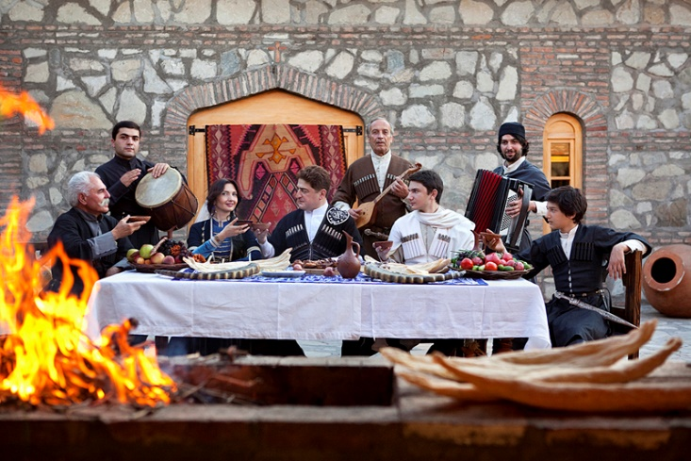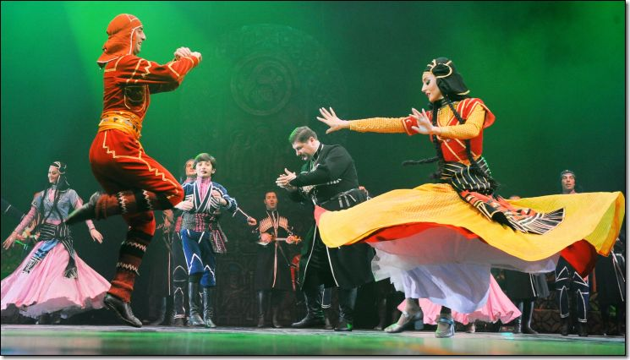

**Beautiful Nature**

Georgia is famous for its picturesque and multifarious nature. This country is gifted with particular nature, mild climate, magnificent Caucasian Range (the summits of which are higher than 5000 metres), Black Sea coastline, numerous lakes, rivers, waterfalls, grottoes and eternally snow-clad summits. There is a remarkable variety of landscape.

The country has much to offer as a tourist destination: a diverse nature from a Sub-tropical Black Sea coast, to the alpine valleys with dramatic mountain picks over 5000 m. from semi-deserts to coniferous woods, nature reserves with many waterfalls and beautiful lakes.

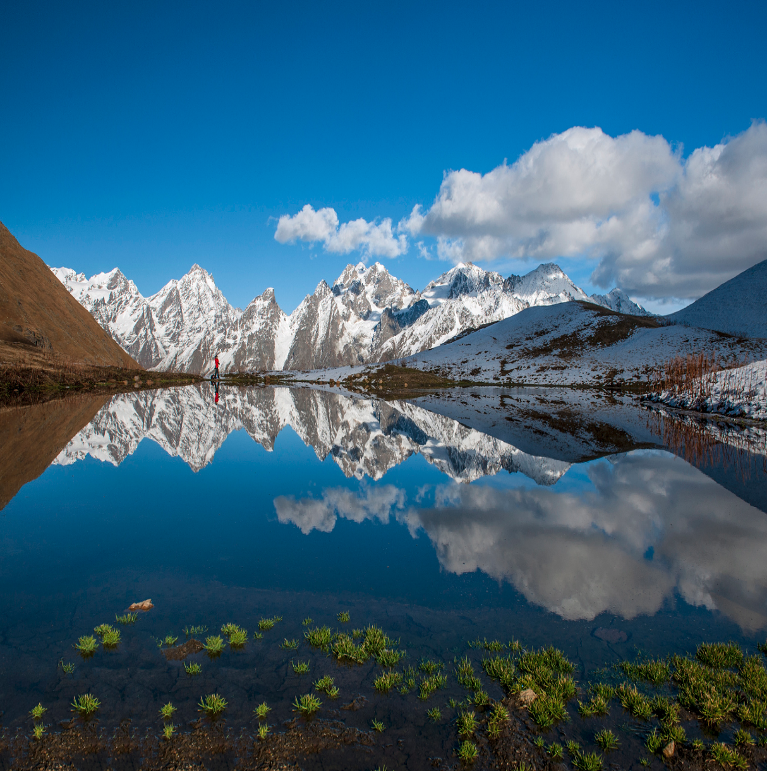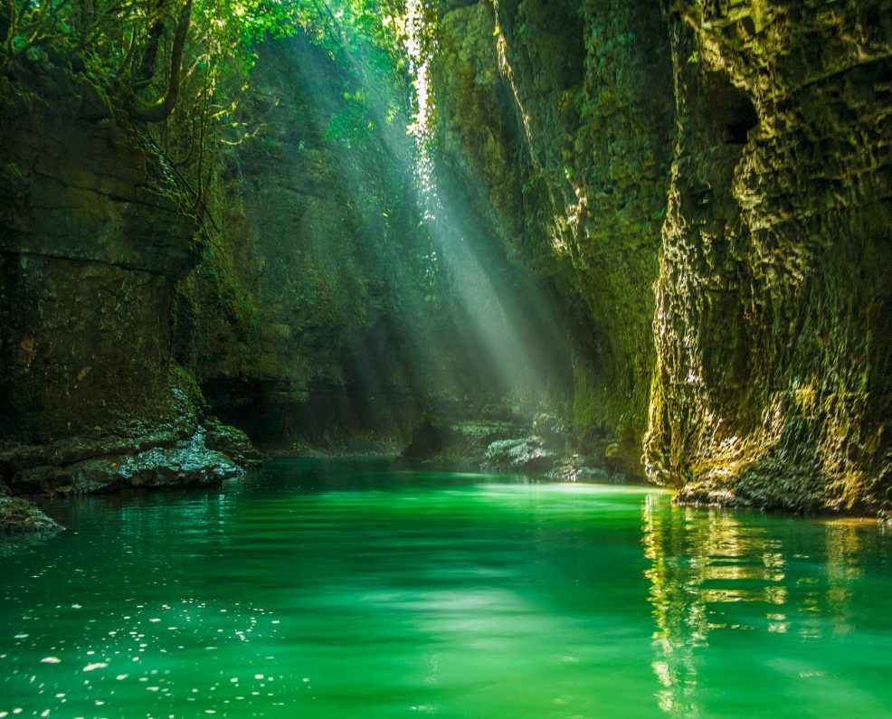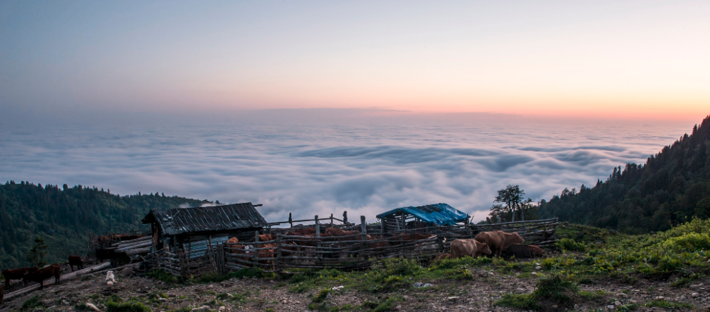

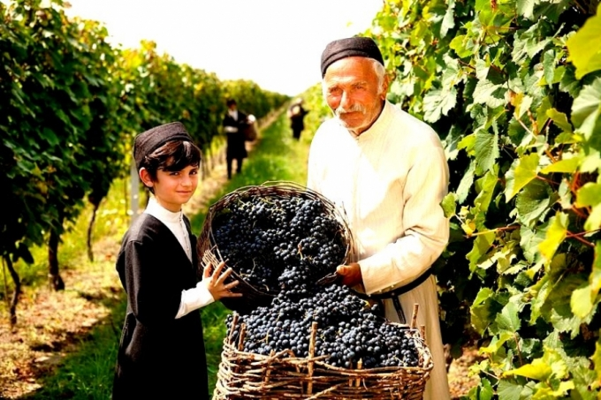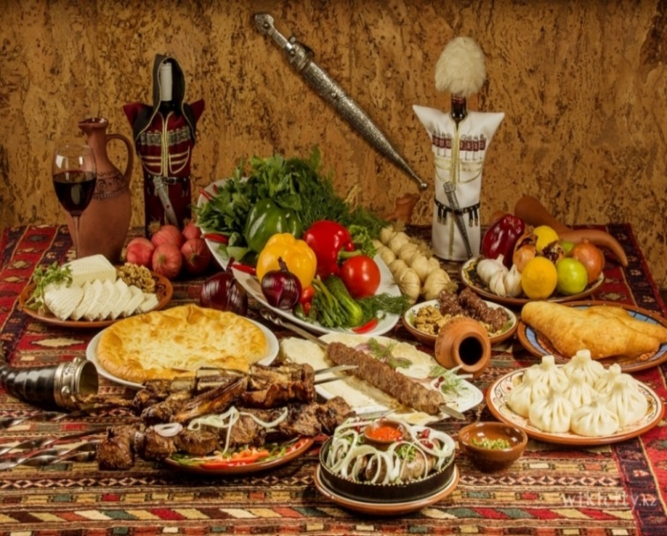**National Cuisine and wine**   
Many discoveries left the historians no doubt that Georgia was the birthplace of wine. Georgian wine is well known for its particular virtues. One of the best ways to experience and understand Georgian traditions of eating, drinking and enjoying life is Supra, the Georgian table. Diversity and specific flavour of Georgian cuisine is based on centuries-old traditions and material culture.

* **ARGONAUTS**

According to Greek legend Georgia’s first recorded tourist group was the group of Argonauts arrived in the ancient land of Kolkhida. Those who know the myth about Argonauts might remember that their leader *Jason* traveled to Kolkhida (Western Georgia) across the Black Sea, in search of Golden Fleece, finally finding his beloved Medea. Furthermore the legend of the Golden Fleece was given credence also by the ongoing Svanetian technique of panning for gold through sheepskins.

* **FIRST EUROPEANS**

Extensive archeological studies and researches made at Dmanisi – in the foothills of the lesser Caucasus, turned the location into one of the most attractive travel destinations of the country and the whole Caucasian Region in general. The discovery of the primitive stone tools in 1984 led to the greater and more important findings. Recently archeologists have discovered the skull of a 1.8 million year old hominid at Dmanisi. This historic find provides a key link to humankind’s earliest transitions between Africa and Europe*.*

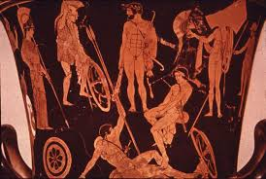

**Tbilisi – the capital city of Georgia founded in 5th century - Architecture in Tbilisi is interesting in many ways: The oldest parts of town clearly have a traditional Georgian architectural look with Near Eastern influences. The areas of downtown Tbilisi, which were built or expanded mainly in the 19th century, have a chiefly Western European look.**

**For more information please find the link:**

<http://www.georgianjournal.ge/discover-georgia/33248-tbilisi-among-21-european-cities-you-never-thought-to-visit--but-definitely-should.html>

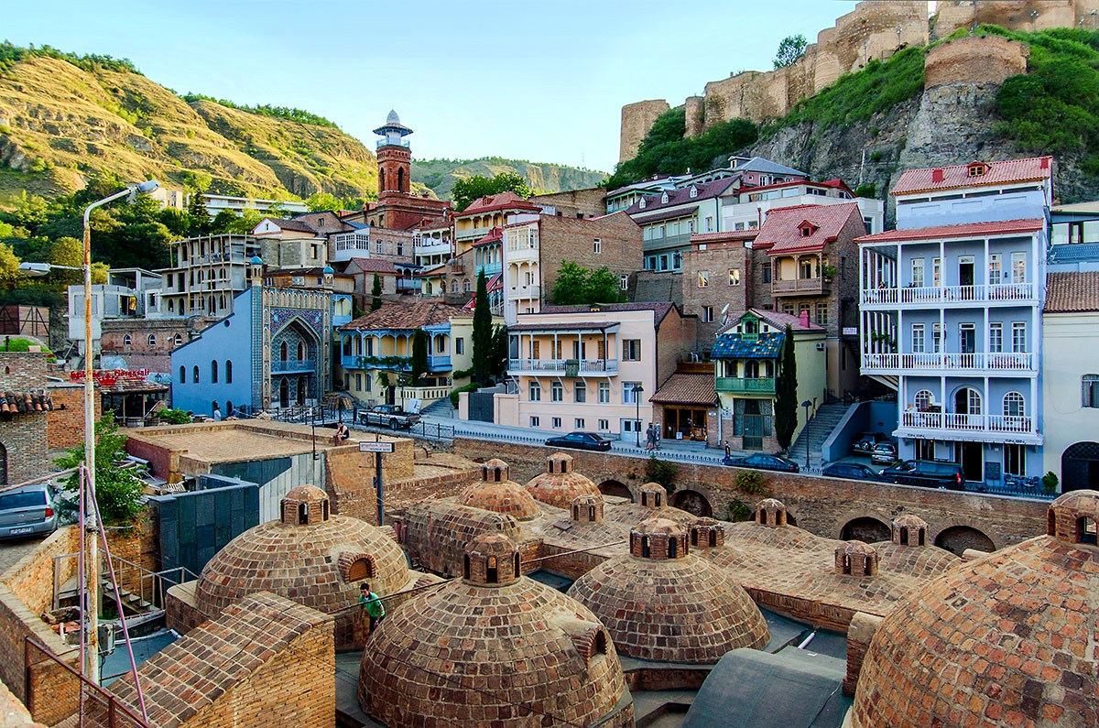

**Why You Should Visit Georgia?**

<https://www.gotravelyourway.com/2013/11/12/8-reasons-to-travel-to-georgia-and-tbilisi/>

<http://edition.cnn.com/travel/article/reasons-to-visit-georgia/index.html>